Geography – Mumbai 1
Keywords |  | - Urbanisation  Urbanisation is increasing globally, today 55% of the worlds population are living in urban areas, this number is expected to increase to 70% by the year 2050. The fastest growth in Urbanisation is in Asia and Africa.  - Mumbai’s location  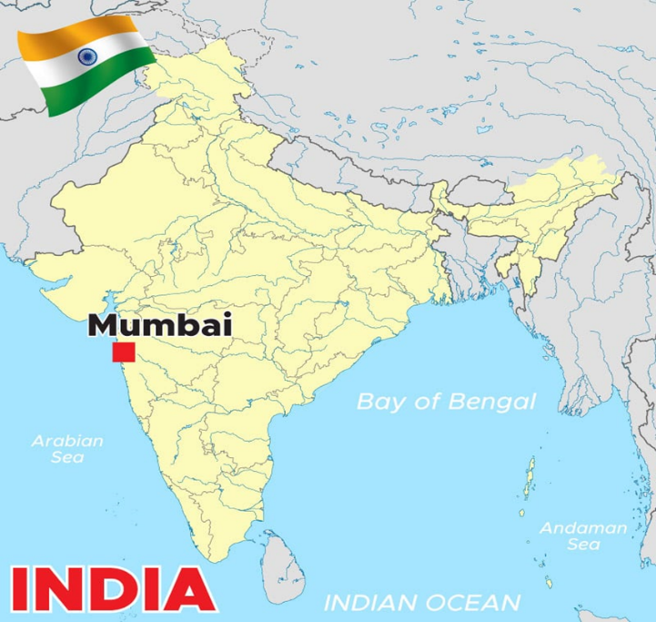  - Mumbai as a global City  India is an NIC, its economy has increased rapidy after the service based economy has been relocated to India. Most of this economic growth has occurred in urban areas however, whilst the rural areas have largely remained in poverty.  Mumbai along with other Cities like London, New York, Beijing and Sao Paulo are classed as global cities through their migration, trade, transport, finance and cultural connections.  Global Transport links in Mumbai are good and include an international airport and India’s largest shipping port. 43% of Mumbai’s population are regional migrants. 1% of Mumbai’s population are international migrants. It is often referred to as ‘Migrants city’. | - Mumbai’s Population  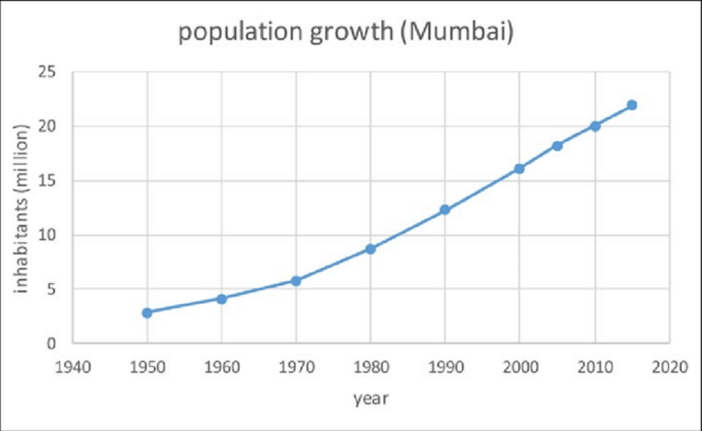  - Migration  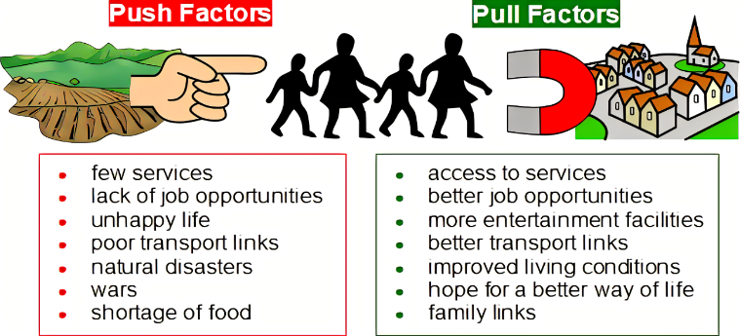  The main reason for Mumbai’s population growth is rural to urban migration.
1.Urbanisaiton | The growth of urban (Cities or Towns) areas
2.Re urbanisation | The movement of people back into a city area that has been previously abandoned
3.NIC | Newly Industrialised Country, a country that is starting to grow its economy.
4.Global City | A City that is well connected to the rest of the world
5. Natural Increase | The difference between a places birth rate and death rate
6. Rural to Urban Migration | The movement of people from rural areas (countryside) into Urban areas (Cities and Towns).
7. International Migration | The movement of people from one country to another.
8.Pull factor | Something that attracts someone to a place
9.Push factor | Something that makes someone want to leave a place
10. Slum | Overcrowded, illegal homes made out of scrap materials.
11. Poverty and Deprivation | A person/area lacking in wealth
12. Quality of Life | A measurement of health and happiness
13. Inequality | A difference between something e.g. wealth
Revision Questions

- Explain why Mumbai is considered a Global City
- Explain why India is classed as an NIC
- Describe the location of Mumbai
- Describe the changes in Mumbai’s population over time, use figures in your answer
- Give 3 rural push factors
- Give 3 urban pull factors
- Describe the differences between Dharavi and SoBo
- Explain why the people in Dharavi have a poor quality of life
- Explain the strategies that aim to improve Dharavi
- What are the positives and negatives of the Dharavi improvement strategies?
Geography – Mumbai 2
9.Dharavi – West coast of Mumbai, north of the CBD. Dharavi is a slum with an estimated 1 million people living there. |  | 6.Bollywood, North Mumbai – Globally famous film industry. Employs 170,000 people.  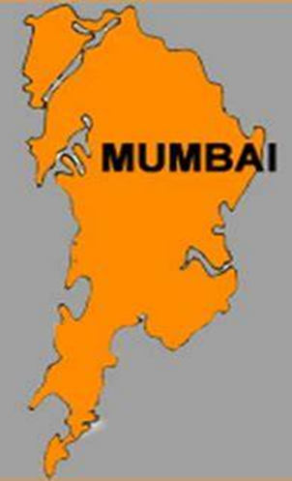  7.CBD South Mumbai – Hub of economic growth, includes TNC’s HQ like Tata Steel who have operations in more than 100 countries globally. The bank of India and Indian stock exchange are located in Mumbai’s CBD.  11. Dharavi Strategies  In 2003 the Vision Mumbai report suggested that $40 billion needed to be invested into Dharavi by both the public and private sector to improve roads and congestion on trains and clearing slum housing replacing it with formal housing.  Bhendi Bazaar slum clearance scheme Replacing slums with sustainable high-rise tower blocks. These had electricity, clean water as well as CCTV for security. The tower blocks are very expensive however so not all from the slums will be able to have one.  Mumbai Mass metro transit scheme A train that will boast 27 stops and reduce cars on the roads by 650,000. Will be particularly useful to connect commuters to the CBD. An example of ‘top down development’ as decisions were made by the government with little input from local people.  Self Help Schemes Small loans given by both banks and NGO’s to help people invest in improving their small business.  8.Sobo – South Bombay – Affluent area, young professionals located here with a high quality of life.
10. Dharavi Challenges
Housing – the housing in Dharavi is made out of scrap materials meaning they are unstable. The housing tends to be overcrowded and lacking in basic sanitation e.g. toilets and clean running water meaning diseases spread easily.
Transport - The trains in Dharavi carry 3X the number of passengers they were actually designed for. Due to overcrowding the tracks lie very close to the houses. On average 9 people die per day on Mumbai's rail tracks.
Waste – As Dharavi is so overcrowded waste is a big challenge. Some waste ends up on the streets and in the rivers of Dharavi which smell, attracting vermin and therefore diseases. The waste can also pile up meaning the little space children have to play out is taken up. 80% of Dharavi’s waste however is recycled by local ‘rag pickers’.

