Geography – Weather and Climate 1
Keywords |  | 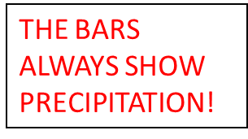  - Climate Graphs  THE LINE ALWAYS SHOWS TEMPERATURE!  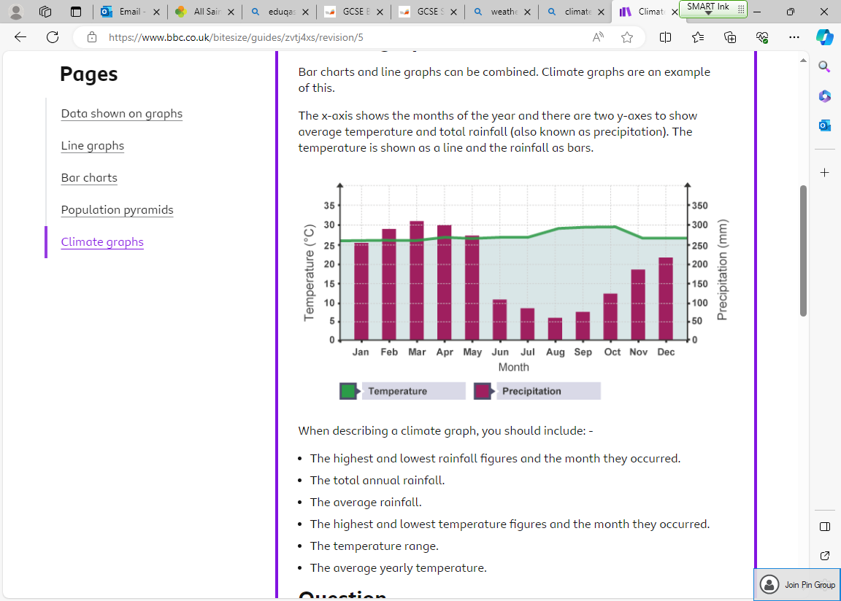  - Factors that affect UK climate  Temperature –  The South of the UK tends to have slightly warmer temperatures than the north of the UK due to latitude. North Scotland (Highlands) tends to have colder temperatures than England due to it sitting at a higher altitude. Additionally, the East of the UK tends to be colder than the West in Summer months and warmer than the West in Winter months as the Atlantic Ocean takes a longer period of time than land to heat up and cool down.  Precipitation –  The West of the UK tends to experience higher precipitation levels than the East. The Atlantic Ocean evaporates, cools and condenses to form clouds which precipitate over the West coast. Additionally, Scotland tends to receive more precipitation than England to due higher altitude so relief rainfall can occur. | - Air pressure  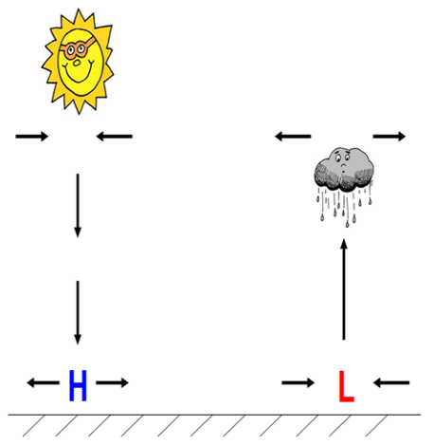  Low air pressure = when air is warmed up, it expands as the molecules become more active and move further apart. This makes each parcel of air lighter, so the air rises and there is less mass pressing down on the Earth’s surface. Warm air =Low pressure = light air = rises = wet weather.  High air pressure = when air is cooled, it contracts as the molecules become less active and closer together. This makes each parcel of air heavier, so the air sinks and there is more mass pressing down on the Earth’s surface. Cool air = High pressure = heavy air = sinks = dry weather.  Air in the atmosphere is constantly moving around as air blows from high pressure areas to low pressure areas to even out the air pressure.  - Climate Zones  Tropical rainforest climate - We find tropical rainforest climates lying on or near the equator, we characterise tropical rainforest climates by high temperatures and year-round rainfall.  Average temperatures are usually around 20–30 °C, with minor variation over the year. Rainfall is over 60 mm of rain in every month, giving rise to thick jungles and some of the highest biodiversity seen on land.  Semi-arid climate – Found in Northern Africa as well as Australia the semi-arid is a dry climate but not as dry as a desert. A lack of precipitation for the majority of the months out the year then 100 mm of rainfall for just a couple of months. Average temperatures of 20 °C but can reach 40 °C in summer months. Small plants and shrub like grasses grow here.
- Weather | The day-to-day conditions of the atmosphere at a particular place.
- Climate | The average weather conditions of a place taken over a long period of time, typically 30 years.
- Latitude | Distance from the equator.
- Altitude | Height above sea level.
5. Air Pressure | The weight of the air.
6. Troposphere | The lowest region of the atmosphere, extending from the earth's surface to a height of about 5-9 miles.
8. Anticyclone | An area of high atmospheric pressure where the air is sinking.
8.Depression | An area of low atmospheric pressure where the air is rising.
9. Hurricane | A revolving storm formed over tropical or sub-tropical oceans.
10. Seasonality | Something depending on the season e.g. weather.
11. Polar Jet Stream | A band of strong winds above the earth.
12. Air Mass | A body of air with uniform levels of temperature, humidity, and pressure.
Revision Questions

- What is the difference between weather and climate? (2 marks)
- Explain Mansfield’s weather and climate (4 marks)
- Describe the climate graph (6 marks)
- Define altitude and latitude (2 marks)
- Explain the temperature differences found across the UK (6 marks)
- Explain the precipitation differences found across the UK (4 marks)
- Describe the difference between high and low pressure (6 marks)
- Explain why we have different climates across the globe (2 marks)
- Explain global air pressure patterns (6 marks)
- Describe the formation of a hurricane (6 marks)
- For a named case study explain the cause, impacts and responses to an extreme low-pressure event (8 marks)
- Explain how the jet stream impacts UK air masses (2 marks)
- What weather does the UK experience when a polar maritime air mass is prevalent? (1 mark)
- Describe the weather chart on the next page (4 marks).
- Describe the passing fronts diagram on the next page (6 marks).
Geography – Weather and Climate 2
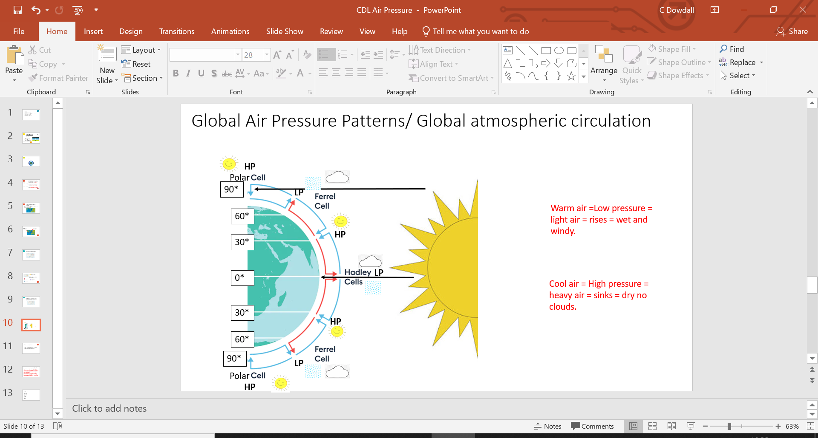  - Global air pressure patterns  Suns heat energy radiates on to the earth, due to the curvature of the earth it is most concentrated at the equator or a 0° latitude. The air here is warm so low pressure occurs. The warm air rises, cools and then condenses to form clouds and rain. This will move 30 ° N&S cooling and therefore turning into heavy air and high pressure which sinks. At 30 ° N&S of the equator the weather will be sunny with no clouds but also very cold at night. This is called the Hadley Cell. At the poles, the furthest distance away from the equator we have high pressure as the air is cold. This air is heavy it sinks to give clear skies and sunny conditions. This is called the Polar Cell. This air travels south to meet the warm air coming from the tropics. The air can’t mix so rises to form low pressure, this low pressure will cool, condense and form clouds and rainfall at 60 ° N&S. This cell is called the Ferrel Cell.  - Air Masses  The UK experiences air masses which bring different weather.  Air Mass Name Where it comes from Weather it brings  Polar Contitnetal Northern Europe Cold and dry  Polar Maritime North Atlantic Ocean Cold and wet  Arctic Maritime Arctic Ocean Very cold and wet  Tropical Maritime South Atlantic Ocean Warm and wet  Tropical Contitnental Southern Europe & Northern Africa Warm and Dry |  | - The Jet Stream  The jet stream impacts, what air masses reach the UK, the track of the jet stream migrates north and south throughout the year. If it flows to the north of the UK, there is a tendency tropical air masses to affect us. However, when its track is further south of the UK there is more likelihood of experiencing polar air masses.  - Weather Charts  Isobars – Show uniform air pressure, above 1020 = high air pressure, below 1020= low air pressure. Lines close together = low air pressure. Lines further apart = high air pressure.  Occluded front – Where a cold front overtakes a warm front, creating clouds and precipitation.  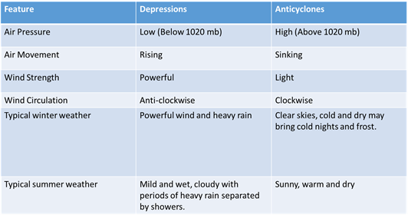  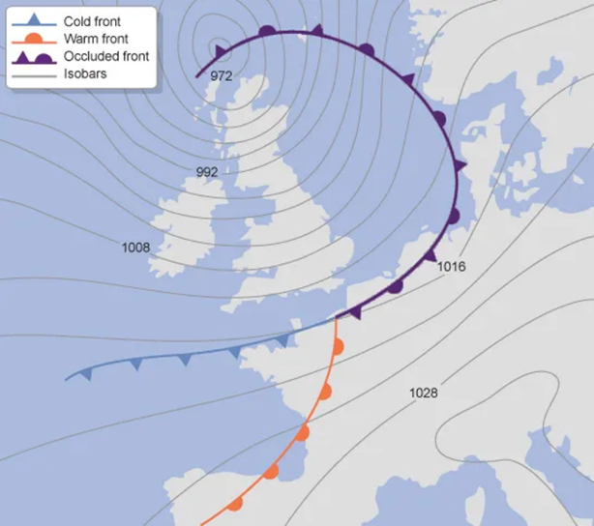  9. Anticyclones and Depressions  Cold front – Colder air mass, brings cloud and precipitation, followed by a decrease in temperature.  Warm front – Warmer air mass, brings cloud and precipitation followed by an increase in temperature. | 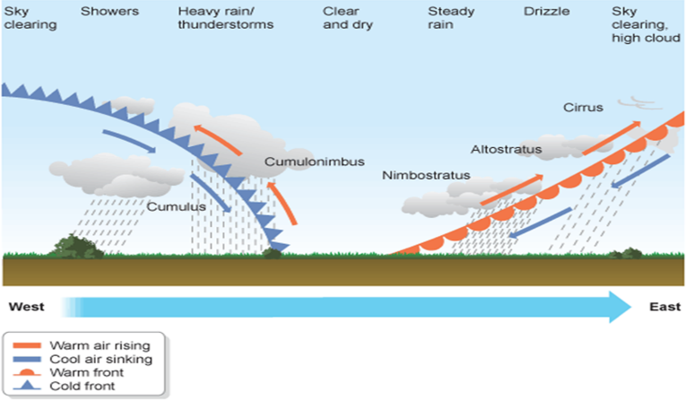  - Passing Fronts  - Extreme low-pressure event – Hurricanes  Formation - Hurricanes form in between the tropics where by water temperatures reaching over 26°C. The water starts to evaporate which means changes from a liquid to a gas. The air that is evaporating starts to spin due to the strong winds/Coriolis force in this region. This air then cools, condenses to form cumulonimbus clouds. The centre of the tropical storm known as the eye is calm. The hurricane loses its energy source (water) once it reaches land and therefore dies out.  - Cyclone Pam case study  Vanuatu is a small LIC in the South of the Pacific Ocean. In 2015 a category 5/5 160 mph wind cyclone hit Vanuatu. Impacts of this include 11 deaths, 90% of homes damaged and $2.5 million worth of agriculture damage. HIC’s including the UK sent money and aid resources to Vanuatu including £2 Million, 92,500 blankets  and 153 temporary schools.

