Geography – Ecosystems
Keywords |  | 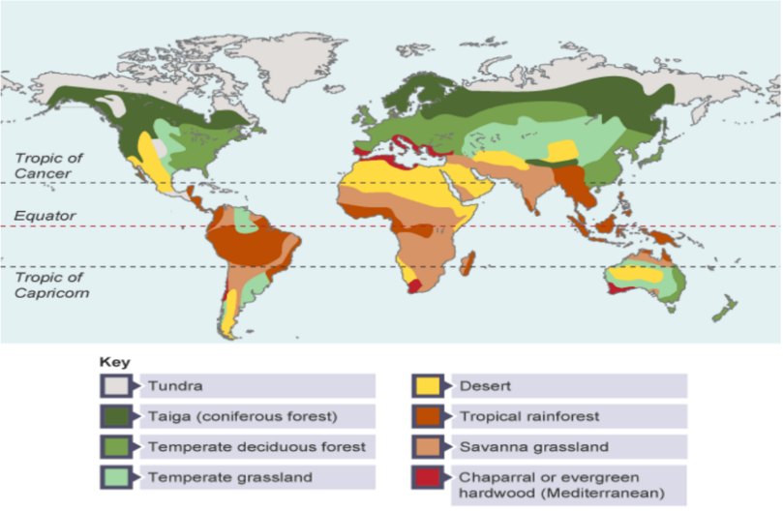  - Biomes location and their characteristics  - Tundra - found near the North and South poles. Very few plants and animals can survive here.  - Taiga (coniferous forest) - found in Scandinavia, Russia and Canada. Evergreen trees thrive in this cool temperate climate.  - Temperate deciduous forest - found across Europe and in the USA. These trees lose their leaves every year and thrive in mild and wet conditions known as a temperate maritime climate.  - Temperate grassland - found in Hungary, South Africa, Argentina and the USA. Consists of grass and trees that thrive in a temperate continental climate of moderate rainfall and mild conditions.  - Chaparral or evergreen hardwood (Mediterranean) - found around the Mediterranean Sea, around Perth and Melbourne in Australia and California in the USA.  - Desert - found near the Tropics of Cancer and Capricorn. Conditions here are very hot and dry. Plants and animals are specially adapted to survive in the harsh conditions.  - Tropical rainforest - found near the Equator. The climate is hot and humid and many different species can be found here.  - Savanna grassland - found mainly in central Africa, southern India, northern Australia and central South America. Long grasses and a few scattered trees are found in these hot and dry conditions. | - Why do we have different biomes across the globe?  Latitude is distance from the equator. The further north or south we go from the equator the colder the temperature gets. This is due to the curvature of the earth; the suns energy has a shorter distance to travel and is concentrated at the equator whereas at the poles it is diffused and has to travel further to get there.  The precipitation levels in each biome are impacted by air pressure type. At the equator as the air is warm, which is light so rises. This is low pressure which causes rainfall. As we get to 30⁰N&S the desert biome region however we experience high pressure, the air here is colder than at the equator meaning it is heavy and therefore sinks causing clear skies. We also experience high pressure at the poles. At 60° N&S in the temperature deciduous forest biome like in England low pressure occurs.  The temperature and precipitation levels impact what plants and animals can flourish in the biome.  - Ecosystems  Ecosystems function when biotic components e.g. plants, animals and decomposers work with abiotic components e.g. temperature, light and moisture.  The nutrient cycle shows how nutrients move through abiotic and biotic parts of an ecosystem. Nutrients within the soil are taken up by biomass, through plants roots (transfer). These plants can also be eaten by animals (transfer). Nutrients can be stored in plants and animals but plants and animals can die which become litter (transfer) in an ecosystem. These nutrients can remain in the litter as a store or this litter can then be broken down by decomposers (transfer) putting nutrients into the soil as a store or a transfer when it gets consumed by plants and animals again.
- Ecosystem | A community of plants and animals and the environment in which they live
- Biome | A large-scale ecosystem
- Abiotic | Non-living
- Biotic | Living
5. Food chain | A series of organisms each dependent on the next as a source of food
6. Food web | A system of all the food chains in an ecosystem
7. Producer | The base of a food chain makes its energy through photosynthesis.
8.Primary Consumer | Consumers producers, a herbivore.
9. Secondary consumer | Consume primary consumers, mainly carnivores.
10. Tertiary Consumer | Top of the food chain, consume secondary consumers, carnivores.
11. Biodiversity | The variety of plants and animals in an ecosystem.
12. Litter | Dead material on the ground.
13. Biomass | The mass of plant or animal material.
14. Decomposers | Bacteria and fungi that break down dead plant and animal matter.
15. Nutrients | A chemical substance needed for plants and animals to grow.
Nationally important nature reserves.
16. National Nature Reserve NNR
Practise Questions
1.Explain the characteristics of the desert biome (2)
2.Explain the characteristics of the temperate deciduous forest (2)
3.Describe the location of the savannah grassland biome (3)
4.What is the difference between a biome and a ecosystem (2)
5.Explain why we have different biomes across the globe (6 marks)
6.What is the difference between biotic and abiotic (2)
7.Name 3 abiotic parts of an ecosystem (3)

Geography – Ecosystems
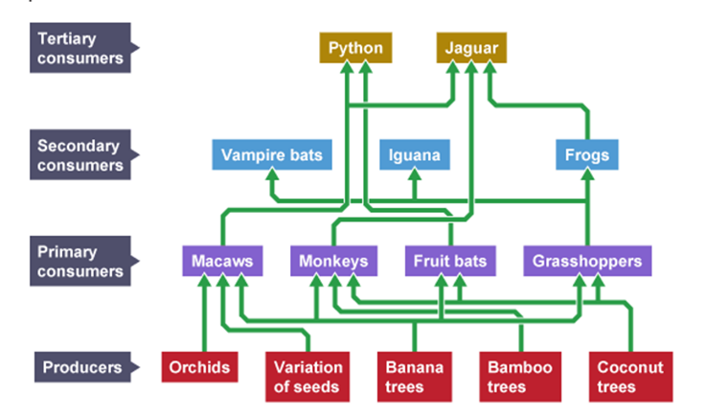  4.Food chains and webs  If one elemenet is taken from a food chain the whole food chain is impacted.  5.Tropical rainforests  Location Tropical rainforests are located on or near the equator inbetween the tropic of cancer and capricorn. For example in South East Asia and North of South America.  Climate The climate of a tropical rainforest is humid or both warm and wet. Temperatures are high all year round between 25-30°C, precipitation levels are also high. Jan-Apr have the highest preipitation levels around 300mm. Jun -Dec have lower precipitation levels around 150 mm.  Vegetation and animals Tropical rainforests have 4 distinctive layers, starting at the forest floor/shrub layer which recieves the least amount of sunlight. The next layer is the crowded understory/undercanopy, followed by the umberella shaped canopy layer, the location which blocks the sunlight and the majority of the plants and animals in TRF live. Finally the emergent layer is the final layer this is sparsely populated with the tallest trees. Various plants and animals have adapted to suit the tropical rainfroest environment including drip tips on leaves to reduce breakage from the heavy rainfall and toucans which have a long beak to be able to grab food from other trees. Plant and animal biodiversity is high in the TRF.  Humans it is estimted that aorund 200 million people live in tropical rainforests, these range from tribal communities who don’t work for profit but subsistence farm, to Cities that have been developed in tropical rainforests. Manaus in Brazil fo |  | a GDP per capita of £6500, income is made mainly from brewing, shipmaking and soap manufacturing.  6.Managing biomes  Humans use, change and modify ecosystems to obtain food to eat/sell, water to drink/sell and energy (HEP) to use for growing populations and consumerist societies. Deforestation is a major issue for the tropical rainforest biome. Deforestation occurs to make room for growing populations, to get timber to make items like furniture, to make room for commercial or subsistence farming and for building roads.  Some ways to manage biomes include selective logging which is when you only deforest trees that have reached a particular height. This allows young trees a guaranteed life span and the forest will regain full maturity after around 30-50 years. Some people would argue this management is still causing deforestation however. Another management technique is debt reduction schemes for countries, ‘Debt for nature swap schemes’ can alleviate poverty as well as protecting rainforests. This scheme relies on the generosity of developed countries however.  7.Monteverde Cloud Forest Case Study  Monteverde is located in North West Costa Rica in the continent of South America. The cloud forest faces the threat of deforestation which is impacting the biodiversity of the area. Monteverde currently accounts for 2.5% of the world’s total biodiversity.  In order to reduce the threats the cloud forest is facing ecotourists resorts such as the Santa Elena Cloud Forest Reserve have been established. They ensure a sustainable future for the cloud forest by:  - Providing payable tours and educational programmes (limited number of people allowed) to educate people on the impacts deforestation is having on the biodiversity of the area.  - Ecotourist stays involve embracing local people’s culture e.g. through the food the tourists eat. This reduced food miles as well as provides local farmers with an income.  - Stalls are set up at the resort for local people to sell their products. Women are particularly encouraged to produce products for the stalls.  - Any income made from tourism is reinvested into biodiversity improvement schemes. | 8. UK Small scale ecosystem – Ynyslas  Ynyslas is located on the west coast of wales. It is just north of Borth, which is a developed tourist hotspot. Ynyslas has a small beach on a spit which is home to plenty of marram grass sand dunes. Ynyslas has one street of residential housing and 2 caravan parks but no other facilities or services.  The local community benefit from tourists who come to see the National Nature Reserve. The tourists rent the caravans as well as spend money in nearby Borth which has facilities like pubs and shops.  However the tourists also bring negatives for example trampling on the marram grass which means the sand dunes are no longer bound together. Other issues include litter and dog fouling.  There are multiple stakeholders who have an interest in Ynyslas including local residents/tourists who are appreciative of the sand dunes because they protect properties/caravan’s from coastal erosion and from flooding. Environmentalists would be happy about the protection of sand dunes as they act as a natural coastal defence so nothing needs to be built which could destroy that ecosystem. Golf course owners/players would not want the sand dunes to be protected because rabbits live in them which then foul over the course. This led to a fence having to be out round the golf course. The local council may not want the sand dunes fenced off as this could put tourists off Ynyslas which reduces income for the area.  Practice Questions  8.Describe how nutrients are stored and transferred in an ecosystem (4 marks)  9.Explain what could happen if coconut trees were deforested in the food chain shown (6 marks)  10.Explain why tropical rainforests are located where they are (3 marks)  11.Give and explain one plant and one animal adaptation in a tropical rainforet (4 marks)  12.Explain 3 reasons why humans use, change and modify ecosystems (3 marks)  13.Explain how Monteverde cloud forest has been managed sustainably (8 marks)  14. Explain how a small scale ecosystem in the UK has been managed (4 marks)

