Geography – Desertification 1
Keywords |  | - Where is Desertification occurring?  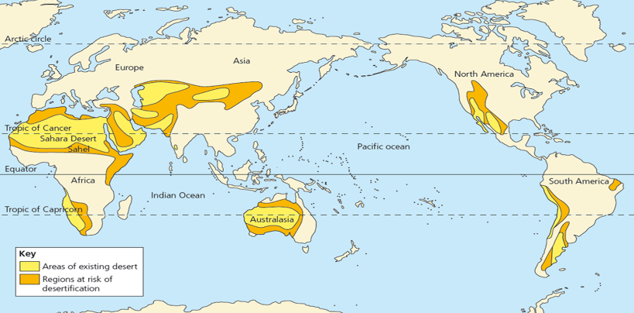  Deserts are increasing globally and they tend to form around areas of existing desert.  The places at risk of desertification or already Desert are 30⁰ North and South of the Equator, surrounding the tropic of Cancer and the tropic of Capricorn. For example, Northern Africa, Western Australia and the Middle East.  - What is the climate of these areas like?  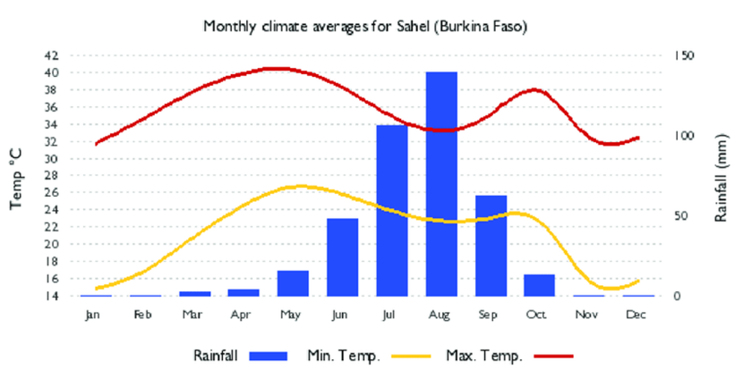  The areas at risk of desertification or deserts are semi-arid. They have high temperatures averaging at 26⁰C all year round. Precipitation rates vary more with a clear dry season of 9 months then a wet season of 3 months where rainfall reaches on average 100 mm a month. | - Why is rainfall becoming more unpredictable?  The Intertropical convergence zone or ITCZ is a belt of low pressure which forms where the trade winds meet, during June-Aug due to the earth’s tilt Northern Africa experiences heavy rainfall from the ITCZ, however the North East tropical continental airmass has been moving further south than usual. This prevents the ITCZ from being able to move North over Northern Africa during these months and therefore decreases the rainfall this area experiences. This causes drought and desertification in Northern Africa.  - What are the human causes of desertification?  - Firewood use – firewood is used for cooking in LIC’s. Deforestation causes soil and rain splash erosion to occur.  - Overgrazing – Animals provide humans with meat however farmers are putting too many animals on their land to increase profit margins. This causes soil and rain splash erosion. Nutrients are also not being put back into soil when vegetation degrades.  - Unsustainable use of water - Precipitation doesn’t occur often in areas at risk of desertification or deserts. When it does fall however people might not be using it in the most sustainable way. The main causes of unsustainable water use are, leaky systems, wasteful field application methods and overabstraction of groundwater resources to keep up with population growth.  - Poor land management - Land is being used to grow food to support growing populations. Farmers in order to keep up with demand and to make profits are trying to grow too many crops too often on their land. This is often the same crop which causes the same nutrients to be used up eventually making the soil useless. Pesticides are also being used on the land to encourage growth of crops, pesticides however deteriorate soil health over time. With roots taken and nothing to bind the soil the land is exposed to soil erosion and rain splash erosion.
- Desertification | The process by which fertile land becomes desert.
- Semi-Arid | An area that has a dry climate but slightly more rain than an arid region.
- Intertropical Convergence Zone (ICTZ) | A band of low pressure around the Earth which generally lies near to the equator. The trade winds of the northern and southern hemispheres come together here. The north-east trade winds come from the Tropical Continental air mass. The south-west trade winds come from the Tropical Maritime air mass.
- Trade Winds | A wind blowing steadily towards the equator from the north-east in the northern hemisphere or the south-east in the southern hemisphere.
5. Micro-climate | The climate of a very small or restricted area.
6. Drought | A prolonged period of abnormally low rainfall.
7. Unsustainable | When something is not able to be maintained at the current rate or level.
8. Soil erosion | The process in which soil is eroded away.
9. Rain splash erosion | Soil being eroded away by precipitation.
10. Evapotranspiration | The process by which water is transferred from the land to the atmosphere by evaporation from the soil and other surfaces and by transpiration from plants.
11. Biodiversity | The variety of plant and animal life in a particular habitat.
12. Subsistence farmer | Growing crops purely for your own consumption.
Farming to make money.
13. Cash Crop farmer
14. Non-Government Organisation (NGO).
A non-for-profit organisation that works independently of any government.

Revision Questions

- Describe the location of desertification globally (3 marks)
- Describe the climate of the Sahel region (3 marks)
- Explain the physical causes of desertification in Northern Africa (4 marks).
- Explain the human causes of desertification in Northern Africa (8 marks).
- Describe the location of the Sahel (3 marks).
- Explain the economic impacts desertification causes (4 marks).
- Explain the social and environmental impacts desertification causes (6 marks).
- Explain how drip irrigation works (2 marks)
- In your opinion what is the best method to manage desertification in the Sahel? (8 marks).

Geography – Desertification 2
5.The Sahel  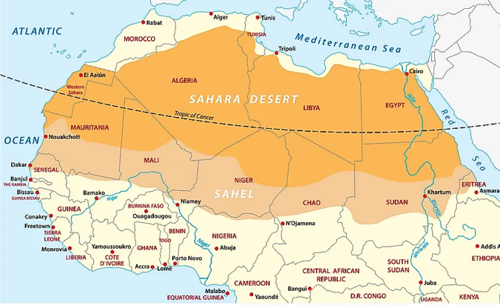  Location –  The Sahel is a semiarid region in western and north-central Africa. The Sahel stretches from the Atlantic Ocean eastward through northern Senegal, southern Mauritania, the great bend of the Niger River in Mali, Burkina Faso, southern Niger, northeastern Nigeria, south-central Chad, and into Sudan.  Environment -  The Sahel has a clear wet and dry season (see climate graph above) which changes the landscape throughout the year from dry and golden/yellow to brown/red with vegetation. The Sahel is a region with rich biodiversity as plants and animals have adapted to suit The Sahel landscape. Acacia trees for example have a large umbrella shaped top to soak up as much rainfall as possible. The Lion has developed a keen sense of hearing and sight to locate prey in the vast Sahelian landscapes.An example food chain in The Sahel = Grasses (producer), mouse (primary consumer), mongoose (secondary cosumer) and Cheetah (predator).  People –  The Sahel region is made up of LIC’s, in Niger for example 50% of its population is living in extreme poverty. Income for most in the Sahel is through farming and fishing. The population in The Sahel is increasing rapidly, it is expected that by 2050 there will be 300 million people in this region of the world. Currently there are 50 million people living here. |  | 6.Desertification in the Sahel  Impacts  Social –  - People (usually women and children) travel further to find water, which means children miss school. In addition, the carrying of heavy loads can lead to back problems.  - People are forced to leave their country and take refuge in another one – refugees.  Economic -  - Commercial farms growing cash crops such as cotton lose income and may cause unemployment.  - With less food being grown and an increase in demand, food prices have increased by 40%.  Environmental –  - Vegetation dies causing animals, which depend on it for food or shelter to perish or migrate (reduced biodiversity).  - On a large scale less trees in the area mean less Co2 is being absorbed.  There are different viewpoints, values and attitudes from stakeholders in this region. For example, subsistence farmers may have tension with cash crop farmers as cash crop farmers often have poor land management in order to make a higher income. | 7.Management of desertification  Local Level Methods -  Drought tolerant crops – planting crops that require minimal water to grow. E.g. Argon trees.  + The drought resistant crops are able to be traded globally to make a profit.  -Seeds are required, the seeds are more expensive than non-drought tolerant crops.  Drip irrigation – a micro-irrigation system that delivers water slowly and directly to the roots of plants or to the soil surface through a network of pipes, tubing, valves, and emitters.  +Uses water sustainably  -Expensive, unaffordable technology for some people in the Sahel.  Magic stones – Stones placed in a half moon shape to encourage infiltration.  +Stones are available and free in the Sahel  -Requires precipitation to be useful  International methods –  The Great Green Wall -  In 2007 a large number of partners including the African Union, World Bank and United Nations started working together to build a row of trees from Djibouti, across 9 other countries to Senegal.  In 2017 15% of the project was complete, the majority of this progress was from just 2 countries however Senegal and Niger. Once complete, the Great Green Wall will be the largest living structure on the planet, 3 times the size of the Great Barrier Reef. The project will cost $2 Billion. It will sequester 250 million tons of carbon and create 10 million green jobs by 2030.

