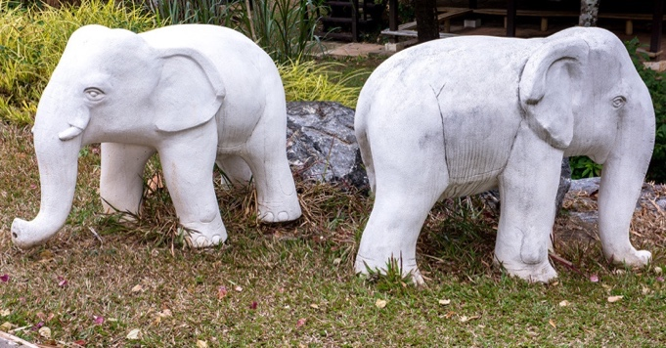

**Samsara**- Cycle of rebirth

**Dhamma (Pali)/ Dharma (Sanskrit)-**

The ‘truth’ about existence

*Languages

Pali- early scripture

Sanskrit – late scripture

AQA BUDDHISM: *BELIEFS AND TEACHING*

**Siddhartha**- ‘perfect fulfilment’

Prince, son of Queen Maya and King Suddhodana. After enlightenment known as the Buddha.

**Jataka-**

Tales about the life of the Buddha.

**Buddha**- ‘the enlightened one’

Title given to someone who has achieved enlightenment, notably used to refer to Siddhartha Gautama.

**The Five Ascetics**-

Buddhas first students, monks who followed asceticism

**Enlightenment**-

Through meditation and self-discipline, it is the gain of true knowledge of

* God
* The Self
* Nature of Reality

Buddhism: gaining of ultimate freedom (Nirvana) by breaking the cycle of rebirth (samsara).

**The Four Sights** –

First four encounters of suffering and the real world by Siddhartha

1. Old Age
2. Illness
3. Death
4. A Holy Man

**Meditation**-

Calming practice to focus the mind. Deep reflection to understand true meaning of life.

Siddhartha hoped to understand the existence of suffering on the journey to the true meaning of life.

**The Three Watches of the Night**-

Realisations Buddha made to achieve Enlightenment

* Knowledge of previous lives
* Understanding of cycle of life, death and rebirth. Born on basis of Kamma (actions) and the importance of anatta (no fixed self)
* Why suffering exists and how it can be overcome

**Kamma (Pali) / Karma (Sanskrit)-**

Skilful actions result in happiness, unskilful actions result in suffering

**Dependent Arising**-

Idea that all things arise in dependence upon conditions.

**Ascetic**

A simple life with no possessions or pleasures. Also includes ignoring needs of the body such as food, rest, temperature, dangers.

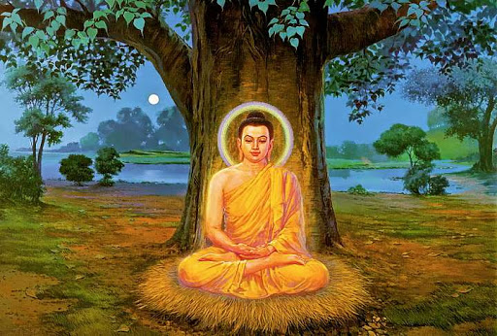

**Seven States of Suffering**-

1. Birth
2. Old Age
3. Sickness
4. Death
5. Despair
6. Contact with the unpleasant
7. Not getting what one wishes for

**Channa-**

Siddhartha’s attendant and chariot driver

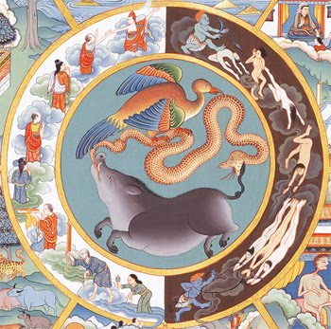

**Anicca**-

Nothing is permanent, everything changes

(Second Mark of Existence)

**Tanha**-

Meaning, to crave

**The Three Poisons**-

Main causes of suffering

1. Greed (cockerel)
2. Hatred (snake)
3. Ignorance (pig)

**The Four Noble Truths**-

1. Suffering exists (Dukkha)
2. Suffering is caused by something (Samudaya)
3. Suffering can end (Nirodha)
4. There is a way to bring suffering to an end (Magga)

**Nibanna (Pali)/Nirvana (Sanskrit)-**

Meaning, extinction. Extinction from the Three Poisons. State of complete enlightenment, happiness and peace. Ultimate liberation from samsara.

**Nidanas**-

12 stages of the Wheel of Life illustrate the process of birth, death and rebirth.

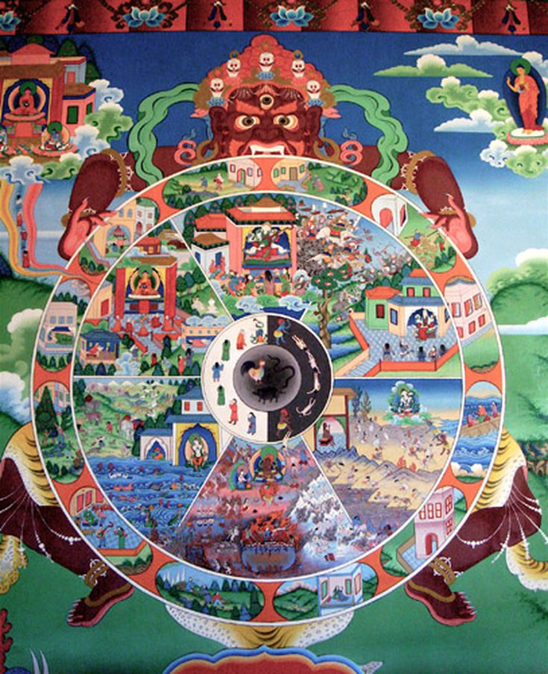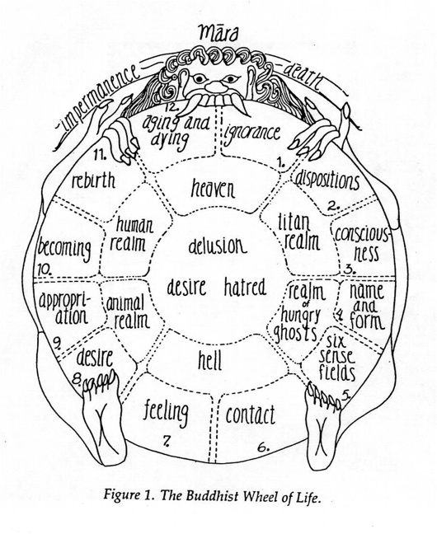

**Dukkha-**

First noble truth: life is suffering (First Mark of Existence)

Three types:

* Suffering
* Change
* Attachment

**The Five Aggregates-**

What makes up human beings

1. Form (body)
2. Sensation (feelings)
3. Perception (recognition of things)
4. Mental Formations (thoughts)
5. Consciousness (awareness)

**Mara**-

A demon that represents spiritual obstacles.

e.g. temptation, physical suffering, material wealth, physical vulnerability

**Anatta-**

No fixed self. People do not have a fixed soul

(Third Mark of Existence)

**Tibetan Wheel of Life**-

Image that symbolises samsara, found in Buddhist temples and monasteries.

**The Eightfold Path**-

Eight aspects that Buddhists practice and live by in order to reach Enlightenment.

Ethics (sila)

1. Right Speech
2. Right Action
3. Right Livelihood

Meditation (samadhi)

1. Right Effort
2. Right Mindfulness
3. Right Concentration

Wisdom (panna)

1. Right Understanding
2. Right Intention





**Ethics (sila)-**

Emphasizes importance of skilful action as the basis for spiritual progress.

**Meditation (samadhi)-**

Emphasizes importance of meditation as a process of spiritual development

**Wisdom (panna)-**

Emphasizes the importance of Buddhist approaches to the nature of reality.

**The Threefold Way**-

Ethics (sila), Meditation (samadhi) and Wisdom (panna).

Main ways to aid spirituality.

**BUDDHIST PLURALITY**

**Arhat-**

Transl. ‘perfected person’.

Use it to refer to someone almost at enlightenment.

**The Five Aggregates-**

What makes up human beings

1. Form (body)
2. Sensation (feelings)
3. Perception (recognition of things)
4. Mental Formations (thoughts)
5. Consciousness (awareness)

**Theravada Buddhism-**

* Thera, transl. ‘elder’

Vada, transl. ‘school’

* Orthodox.
* Ancient Buddhism
* Thailand, Sri Lanka, Laos, Cambodia
* Often live like the Buddha, as monks devoting whole lives to achieve enlightenment and nirvana.
* Five Aggregates

**Mahayana Buddhism-**

* Term for many versions of modern Buddhism. E.g. Tibetan Buddhism, Zen Buddhism.
* China, Tibet, Japan, South Korea, Vietnam, Mongolia, Bhutan.
* Importance to the Four Truths but also other teachings like compassion, Sunyata, Buddha-nature and Buddhahood.

**Pure Land Buddhism-**

* China & Japan
* Belief in Amitabha Buddha, who created a pure land called Sukhavati.
* Faith in and worship to Amitabha will allow Buddhists to reach the pure land.

**Buddha-nature-**

Everyone has the essence of Buddha within them.

Each person has to realise they are already enlightened deep down, must cast out desires, attachments, ignorance and negativity to expose it.

**Buddhahood-**

When someone achieves enlightenment.

Every person is already enlightened, hold a Buddha nature so is able to achieve Buddhahood.

**The Six Perfections-**

1. Generosity
2. Morality
3. Patience
4. Energy
5. Meditation
6. Wisdom

**Bodhisattva-**

A Buddhist Guide.

Through compassion, a Bodhisattva remains in samsara to help others achieve enlightenment.

Capable of the Six Perfections.

Both Earthly Bodhisattvas and Transcendent Bodhisattvas.

Some Buddhist pray to them for help.

**Sunyata-**

Transl. as ‘emptiness’.

Nothing has a separate independent self.

Restatement of Anatta