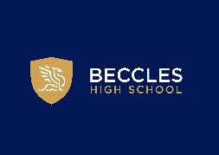
Careers Education, Information Advice & Guidance (CEIAG) Policy
Revised January 2026
Review scheduled September 2027
CEIAG Vision:
Fostering our students’ curiosity and self-awareness, empowering them to become responsible, respectful and valued members of the community who are ready to meet the challenges of their future with confidence.
We strive to prepare our students to be active learners through our embedded, inclusive, skills and experience- rich careers programme.
In partnership with our community, industry contacts, Higher and Further Education providers, we create learning opportunities both inside and outside the classroom fostering our students’ curiosity and self-awareness, empowering them to become responsible, respectful and valued members of the community who are ready to meet the challenges of their future with confidence.

Beccles High School CEIAG Vision aligns directly with the whole school vision, curriculum intent and development priorities:
We strive to prepare our students to be active learners through our inclusive, skills and knowledge- rich curriculum. In partnership with our community, we share the goal to create learning opportunities both inside and outside the classroom. Our students aspire to become responsible, respectful and valued members of the community who are ready to meet the challenges of the future with empathy.

Our Careers Programme has been developed to directly address all of these priorities, embedding them throughout the curriculum, culture and ethos of the whole school. The three themes, Partnerships, Community and Curriculum, encompass our successful work experience programme for Year 10s; the inclusive support for SEND students and their support networks; our ever increasing interactive network of industry, FE/HE partners and community connections and the proactive relationship between our Careers Advisor, Careers Lead and all our staff that reinforces CEIAG as part of our culture.

Beccles High School has an active partnership with the Norfolk and Suffolk Careers Hub and is proactive in its interaction with East Suffolk Council, Suffolk County Council and Suffolk Chamber of Commerce.

Quality in careers:
‘Career’ describes our journey through life, learning and work.

2019 research by Education and Employers, entitled ‘Motivated to achieve’ shows that participation in career talks with volunteers from the world of work can change the attitudes of Key Stage 4 (14-16 years old) pupils to their education. This can influence their future plans and subject choices, motivate them to study harder and supports an improvement in academic attainment.

Setting the integration of Partnerships and Community into Curriculum as Beccles High School’ Strategic Objective delivers this impact for our students. The comprehensive strategic careers programme encompasses processes that ensure a Quality Standard in our programme.
i.e.
- A structured careers programme is written down, published, routinely reviewed and undergoes measured evaluations. Systematic feedback from pupils, parents, local employers and teachers is sought and communication about the programme with all stakeholders is routine.
- There is an individual responsible for careers who is, or is directly line led by, a member of SLT.
- Students are aware, and understand, the careers programme, its purpose and the impact it has on their future life, learning and work.
- Students know where and when they can find CAIEG, and can access their career pathway records.
- School leadership gives CPD time to CAIEG and routinely reiterates its importance and the school’s commitment.

Framework:
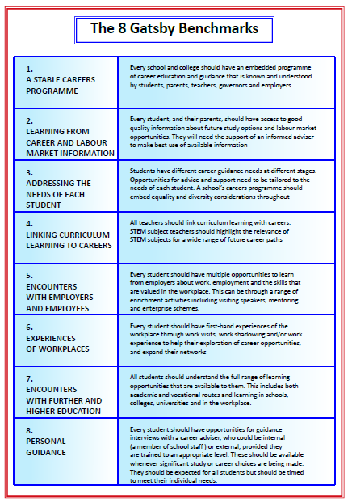

Objectives:
Beccles High School Strategic Objectives
Strategic Objective | Meeting Gatsby Benchmarks
Strategic objective 1. Partnerships  Develop strong proactive partnerships, between the school and employers, employees and HE/FE providers, that deliver a wide range of encounters to broaden and challenge students’ awareness of opportunities in line with Provider Access Legislation.  This includes:  - A full programme of in school careers activities that utilise employer and employee partnerships and is written into the school calendar.  - PSHE lessons, augmented by partners, cover future plans and career management skills as part of the curriculum map.  - All Yr10 take part in work experience outside of school.  - A developing programme of Modern Work Experience encompasses both Key Stages 3 and 4.  - Local post-16 providers, apprenticeship service providers and major local employers who offer apprenticeships attend careers fairs and interactive sessions with students during the school day.  - Trips to post-16 providers and businesses are part of the careers programme.  - Staff, students, parents and employers are aware of, are involved with and feed back on the careers programme  - Use of various methods of communication to include partners and stakeholders in the careers programme is integrated into routine. | Gatsby Benchmark  2, 5, 6 & 7
Strategic objective 2. Community  Create supported opportunities for our students to grow their own networks, build social capital, personal responsibility and empathetic community mind-set, whilst developing great employability skills.  Build mutually beneficial interactive connections between the school and the community in which it sits. | Gatsby Benchmark  2, 3, 5, 6
Strategic objective 3. Curriculum  Integrate careers education across the curriculum with all staff being aware of their role and taking a proactive part in contextualising subject knowledge and transferable skills in the world of work. | Gatsby Benchmark 1,2,3 and 4

Strategic Objective 2.
Community
Create supported opportunities for our students to grow their own networks, build social capital, personal responsibility and empathetic community mind-set, whilst developing great employability skills.
Strategic Objective 3.
Curriculum
Integrate careers education across the curriculum with all staff being aware of their role and taking a proactive part in contextualising subject knowledge and transferable skills in the world of work.
This includes:
- At least one 1-2-1 CPD session for each subject lead with Careers Lead every school year.
- At least one careers focused CPD session for all staff – based on training needs audit.
- At least three careers activities written into each scheme of work Yr7 – 11
- Staff feel empowered and confident in engaging in careers conversations and guiding students with their choices.
- Students understand how their education helps them to develop the fundamental skills and knowledge to achieve success.
- Students are motivated to engage in learning and strive for high attainment as they are aware of achievable aspirational opportunities and understand how their abilities will help them to achieve these aspirations.
- Every organised careers activity links back to, and highlights, relevant aspects of curriculum subjects.
- Links from careers activities to curriculum subjects are linked forward for students to their relevance in job roles/accessing job roles.

The Careers Learning Journey:
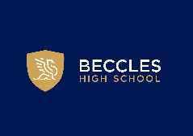
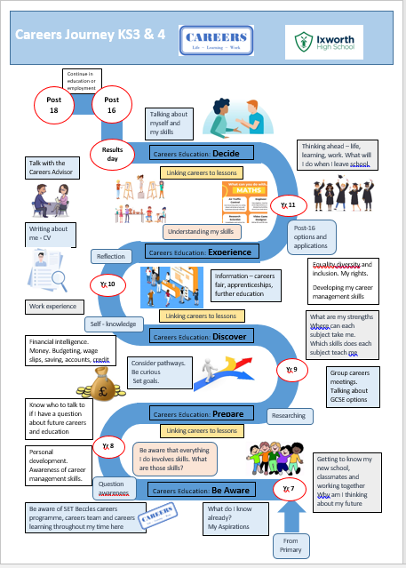

Beccles Careers Programme 2024/2025:

Beccles High School Careers Programme 2024/2025

Stakeholders:
There are a regular careers update newsletters which will share the positive impact of some of our careers programme activities, give notice of upcoming events and opportunities and invite feedback and suggestions.
We facilitate networking within the school that includes talks to and from employers, providers and stakeholders. We are also building links with the local community and business networks outside the school, sharing upcoming topics via talks or appropriate articles and inviting interaction.
The Careers Leader and Careers Advisor attend appropriate parents evenings, options evenings and careers fairs and staff CPD/INSET days to provide updates, impact and reviewed programme objectives.
When possible, social media and LinkedIn posts share information

Partners:
Beccles High School works closely with the Suffolk and Norfolk Enterprise Advisor Network and the Careers Hub.
Regular collaboration and contribution comes from many sources, including but not limited to:
Apprenticeships Suffolk
DWP
East Suffolk Council
Amazing Apprenticeships
Post-16 and Post-18 providers
Our database of business contacts
Our database of work experience placements
Business networks and organisations such as Suffolk Chamber of Commerce, Growth Hubs, local business associations.
Community groups

Student entitlement/goals for students:
We deliver individual and impartial CEAIG that helps students to prepare for the workplace by providing a clear understanding of the world of work including the routes to jobs and careers that they might find engaging and rewarding. It supports them to acquire and articulate the self-development and career management skills they need to achieve positive employment destinations. This helps students to choose their pathways, improve their life opportunities and contribute to a productive and successful economy.

Students and their parents/carers/supporter can request a meeting with the Careers Advisor at any time during their school journey at Beccles High School and are able to access information recorded by the school about their interests and aspirations.

Students and parents all have access to Unifrog. Students can build up skills and activity records on their profiles and explore opportunities.

Monitoring and evaluation:
Records of careers activities, student meetings with the Careers Advisor, destination data and student interests and ambitions are maintained on Compass+ and on Unifrog. A termly Compass+ report is submitted to monitor the school’s progress with Gatsby Benchmarks. Students are permitted access to their Compass+ records on request. They have free access to Unifrog.
Each significant activity, and the careers programme as a whole, is evaluated in an appropriate manner and the data recorded. This data informs review and development of the programme.

Student, parent and partnerships voices play an important role in the development of the programme

There is an annual Trust visit looking at how the school is performing against Gatsby Benchmarks and, importantly, the quality of evidence that has allowed the school to rate itself against each Benchmark on Compass +

Personnel and contact details:
The school Careers Adviser is Ms Stockman, who meets with our students in year 9 for group discussions aimed at equipping students with the information about future pathways from subjects to fully inform their GCSE choices. She also meets each year 10 and 11 student at least once. Parents/carers/support network can attend on request or by approval of the student.

The school Careers Leader is Ms Stockman. She is responsible for the creation. implementation and monitoring of the careers strategy and the careers programme. This includes a series of CPD workshops and 1-2-1s for staff to ensure they are accessing all the resources they need to embed careers in their teaching or support of students.
The Careers Leader will co-produce with SLT and staff, a programme of careers activities throughout the school year and ensure all are empowered to lead effectively on their meaningful careers activities, can evidence impact and record activities via an agreed process.

Ms Stockman can be contacted via email
j.stockman@beccleshighschool.org
The Trust Careers Lead is: Kirsty Bray (k.bray@setrust.org) her role is to support the schools source and deliver a careers programme that meets the Gatsby Benchmarks, working with external parties as required and coordinating termly meetings of school Careers Leads to share pertinent and relevant information that can be drawn into each school’s careers programme. The Trust arranges, in conjunction with each careers lead, an annual careers audit and review and a short written report against the Gatsby Benchmarks is produced.

The Trustee with the Careers oversight is: Jenny Dwyer

