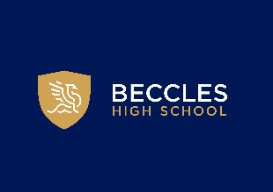

Careers Education, Information, Advice and Guidance

Information for Parents and Carers

Issued Jan 2026. Review scheduled September 2027
At Beccles High School we are committed to working with you to ensure that your child is able to make confident decisions about their options at the end of Year 11 and beyond. We will cover the range of options that are available, including sixth form, college, T-Levels, university, apprenticeships, employment with training and volunteering.
Our local Further Education Colleges, Sixth Forms, Universities and employers are invited into school to help us carry out a range of activities for students in line with our Provider Access Legislation Policy. Students take part in timetabled Careers lessons from Year 7 as part of PSHE and access individual careers appointments with our qualified Careers Advisers in Years 10 and 11. In addition to this, we run a programme of careers and enterprise events each year, which include enterprise days, Year 10 work experience, employer talks, college and university talks and visits, guest speakers in assemblies, school trips and workplace visits.
We welcome the opportunity to speak to parents at our open events, careers fairs and options evenings and encourage parents to contact the careers team to discuss specific aspects of our careers provision or should they have any queries relating to their child.
We are always pleased to hear your feedback on the careers activities that your child has taken part in and to receive any general feedback on our careers programme.
We believe that by working with you, and ensuring that all students receive a high level of careers information, advice and guidance, that they will be best placed to make informed decisions about their future.

Useful Careers Websites

As a school we now subscribe to Unifrog - The universal destinations platform. Every parent/carer is access this independently from their child.
The following websites gives general advice about supporting your child with making decisions about future routes.
https://nationalcareers.service.gov.uk/
https://www.ucas.com/
https://www.apprenticeships.gov.uk/
https://amazingapprenticeships.com/
https://www.icanbea.org.uk/
https://thesource.me.uk/
https://www.lmiforall.org.uk/
https://www.prospects.ac.uk/
https://icould.com/
https://www.futuresforall.org/
https://www.destinationnuclear.com/

